Lab 5 – User Interface Design: List boxes and Trees

Objectives
Today we will learn the use of the following controls:
- ListBox
- TreeView
TASK 1
The ListBox Control
- As the name suggests, the ListBox control displays a simple list of items within a box and is widely used in many Windows applications.
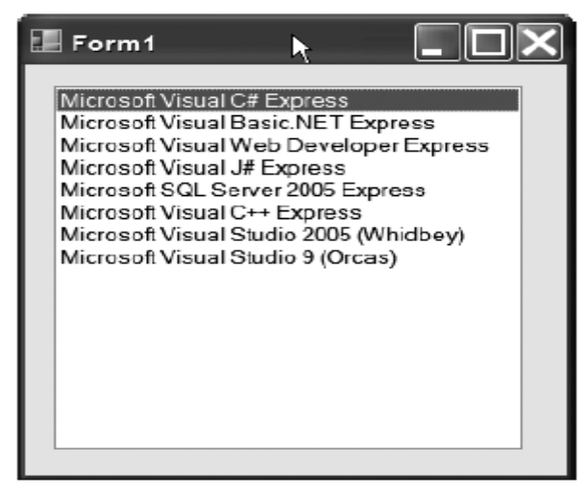
Figure: A simple ListBox Control
- The ListBox control exposes a property called Items that you can use to add items to the list. You can use this property either through code, or even in the Properties window. In the form editor, just drop a ListBox on a form, and then find the “Items” property and click on the button (“…”) in the property’s input area to open the Editor.
- To use the ListBox Control, you will design a simple form (some thing like the one below) where the user could enter a String (e.g. Name of a student) in the TextBox and clicking on the Add Button, the Name would be added to the list.
- Once the list has been created, the user may select an Item and clicking on the second button (Get selected Item), a MessageBox will display the selected string.
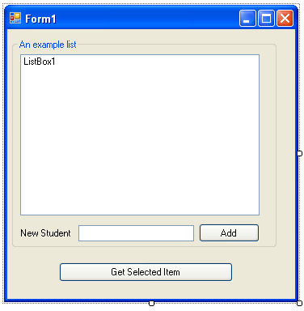
- You could add some thing like this to the Add button:
ListBox1.Items.Add(TextBox1.Text)
TextBox1.Text = ""
- The Items property on the ListBox is something called a Collection. Collections have an Add () method on them to add new items into the collection. In the case of ListBox.Items, this translates to adding an item into the list box. So, the code just takes the string of text entered into the text box and adds it into the Items collection. When that’s done, the text box is cleared out, ready for the next piece of text to be entered.
- To get the selected item from the list you may use:
string selected = Convert.ToString(listBox1.SelectedItem);
The TreeView Control
- The TreeView control is a unique list control, in that it displays a hierarchical view of data. You can find the TreeView Control in Windows Explorer.
- The TreeView holds a Nodes collection, each item in which is a TreeNode object. Each Node itself may contain a Collection of Nodes.
- You can change the actual view of the nodes by associating graphics with them.
- Create a Form and add the TreeView Control to it.
- Double-click the ImageList control in the Toolbox to drop it onto the form. The ImageList control is a nonvisual control, so it appears underneath the form. We will use this control to hold the images which will be visible in the Tree.
- You will have on your Form, some thing like this:
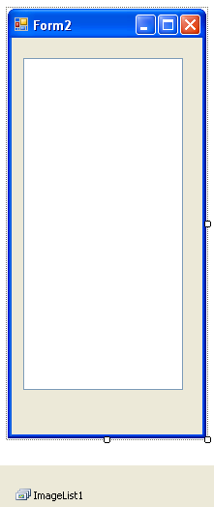
- Select the ImageList Control and in the Properties Window, Go to the Property: Images
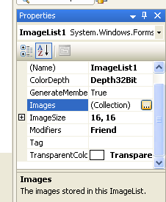
- Add few Images to this Control and return back to the Form.
- Select the TreeView, find the property ImageList and select ImageList1. We are basically telling the Tree control to use images from ImageList1.
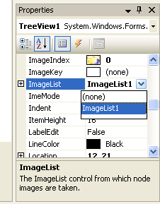
- With the TreeView Control selected, click the Nodes Property to add Nodes to the Tree.
- Using the Add Root and Add Child buttons, you can create a Tree like this:
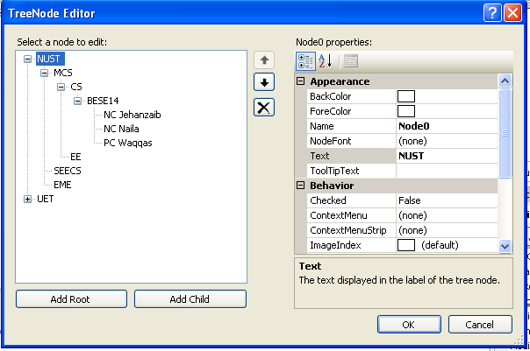
- Use the property ImageIndex of each Node to select an Image that will be associated with the Node.
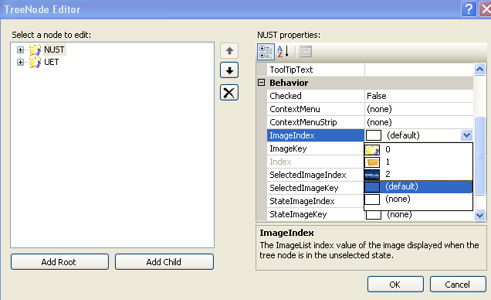
- You can create a Tree and Add a button to the Form. Once clicked, the button displays the selected Node. Following could be used to get the selected item from the Tree
TreeView1.SelectedNode.Text
TASK 2
Employing the controls that you have seen during the last few lab sessions, design a user interface for an Apartment/house search. The user may have the option to search an apartment/house for rent or purchase. You may provide options in terms of city, type (apartment or house), budget, and number of rooms, furnished/non furnished or any other options of your own choice. Once the design is complete, just display the selected options in a MessageBox.

